**Equivalent Fractions**

Two fractions are equivalent if they are reducible to the same rational number.

E.g. 2/4 and 4/8 are equivalent since both represent the rational number 1/2.

This can be shown graphically:

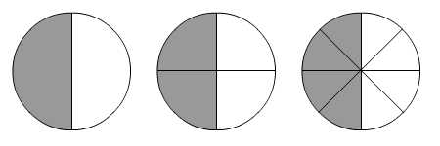

The following are all equivalent to 1/2.

1 1 x 2 = 2 1 1 x 3 = 3 1 1 x 5 = 5

2 2 x 2 4 2 2 x 3 6 2 2 x 5 10

by multiplying (or dividing) the numerator and denominators by a whole number we obtain an equivalent fraction. Note that the numerators and denominators must always be whole numbers.

Try to reduce these fractions to their lowest possible terms:

(e.g. 4/8 reduces to 1/2)

|  |  |
| --- | --- |
| 1. 3/6 2. 5/15 3. 6/24 4. 2/42 5. 2/18 6. 4/10 7. 8/28 8. 12/20 9. 6/9 10. 20/35 | 1. 14/16 2. 15/18 3. 27/36 4. 90/100 5. 36/84 6. 45/25 7. 65/60 8. 72/48 9. 42/42 10. 1008/24 |